Having trouble viewing this form?

When using the Google Chrome web browser, the error message shown below is   
typically caused when Adobe **Reader** (different than Adobe Acrobat)

1. Is not installed   
   -or-
2. Is not set as the default PDF viewer

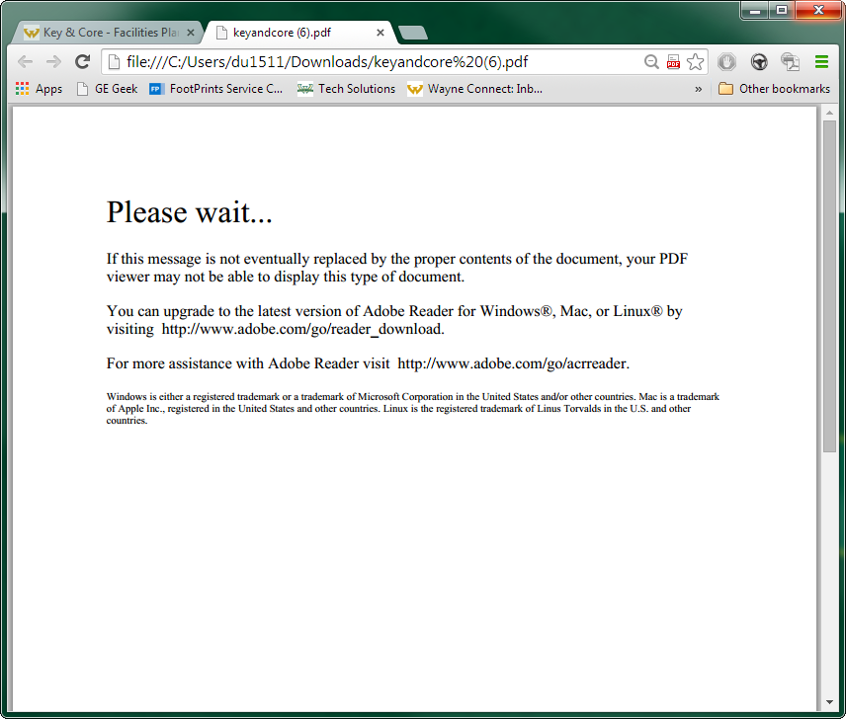

To open a form in Google Chrome, select the PDF icon located at the right end of the address bar of the error message page.

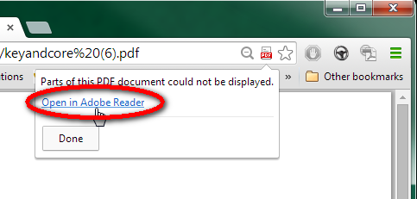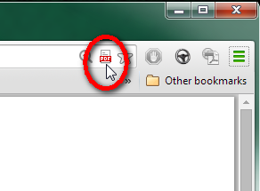

A window will drop down. Select **Open in Adobe Reader**.